
LESSON NOTE | DETAILED EXPLANATORY NOTES
HEALTH AND MEDICAL BIOLOGY
SURGERY - DISSECTION OF ANIMALS

GRADE 12 - BIOLOGY
■ ■ ■

What is Dissection?
Dissection is the careful opening of a preserved animal to expose its internal structures to view - it does not mean to cut up. By dissecting an animal such as the rat, students learn the structure (anatomy) and function (physiology) of the major body systems, and see how those systems are arranged and connected. Because the rat is a vertebrate mammal, almost every structure has an equivalent in the human body, so studying the rat is a safe, practical way of studying ourselves.
It is also an introduction to the surgical skills of careful observation, handling instruments, and working cleanly and safely.
Why Dissect the Rat?
- To identify the major organs and label their structure and function correctly.
- To see the relationships between organs and how their layout makes their functions possible.
- To compare the similarities and differences between the rat and the human body (evidence of common ancestry).
- To practise the safe use of surgical tools and hands-on technique, including stitching.
Surgery - Dissection of Animals
Key Learning Outcomes
By the end of this lesson, students should be able to:
- Dissect an animal and label its structures and their functions correctly.
- Distinguish the major body systems and their functional relationships.
- Compare the structure and function of the rat with the human body.
- Use surgical tools safely and perform hands-on techniques including stitching.
- Work safely and ethically, treating the specimen and equipment with care.
Safety, Ethics and Instruments
Dissection must be done safely and respectfully. Wear gloves (and eye protection where required), handle the preserved specimen and chemicals carefully, keep the work area clean, and dispose of materials properly afterwards. The specimen must always be treated with care and respect. A scalpel is not used - scissors are safer because the points can be kept pointing upwards to avoid damaging the organs beneath. Always raise a structure with forceps before cutting, so you can see what lies underneath.
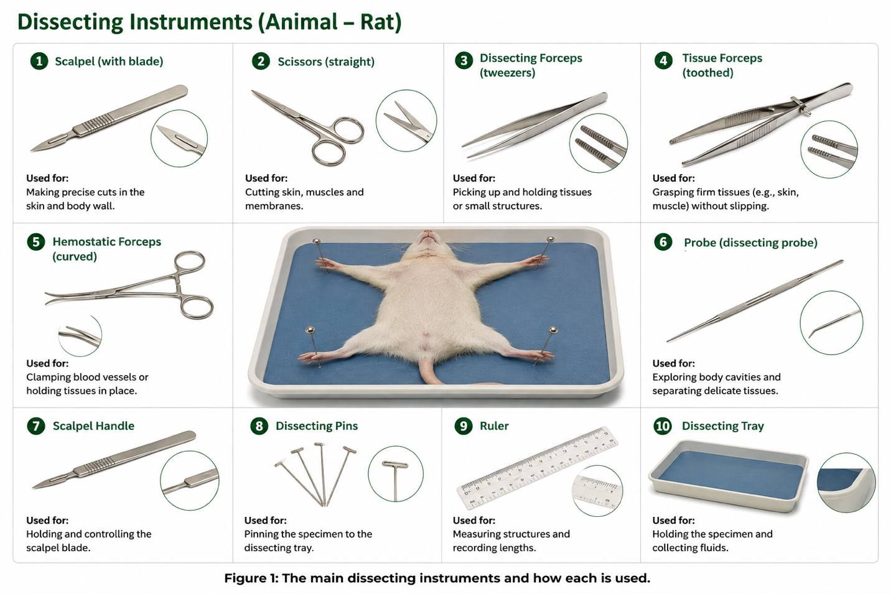
Figure 1: The main dissecting instruments and how each is used.
Glossary of Terms
Useful terms for the dissection:
- Dissection: carefully exposing internal structures to view (not “cutting up”).
- Specimen: the preserved animal; ours is double-injected - arteries filled with red latex, veins with blue.
- Anterior / posterior: towards the head / towards the tail.
- Dorsal / ventral: the back surface / the belly surface.
- Incision: a careful cut made to expose a structure.
- Suture (stitch): joining the cut edges of skin back together at the end.
The Rat as a Specimen
The rat (Rattus norvegicus) is classified as: Kingdom Animalia, Phylum Chordata, Subphylum Vertebrata, Class Mammalia, Order Rodentia, Family Muridae, Genus Rattus, Species norvegicus. Because it shares the basic body plan of all vertebrates, its organ systems closely match a human’s. Specimens are usually double-injected with red latex (arteries) and blue latex (veins) to make the blood vessels easy to follow.
External Anatomy and Body Regions
Before opening the rat, the external anatomy is examined. The body is divided into six regions - cranial (head), cervical (neck), pectoral (front legs), thoracic (chest), abdomen (belly) and pelvic (hind legs). External features are noted: the fur and sensory whiskers (vibrissae), the large gnawing incisors, the eyes with a nictitating membrane, the ears (pinna), the hairless tail, and the features that distinguish the sexes (teats and the vaginal opening in females; scrotal sacs in males).
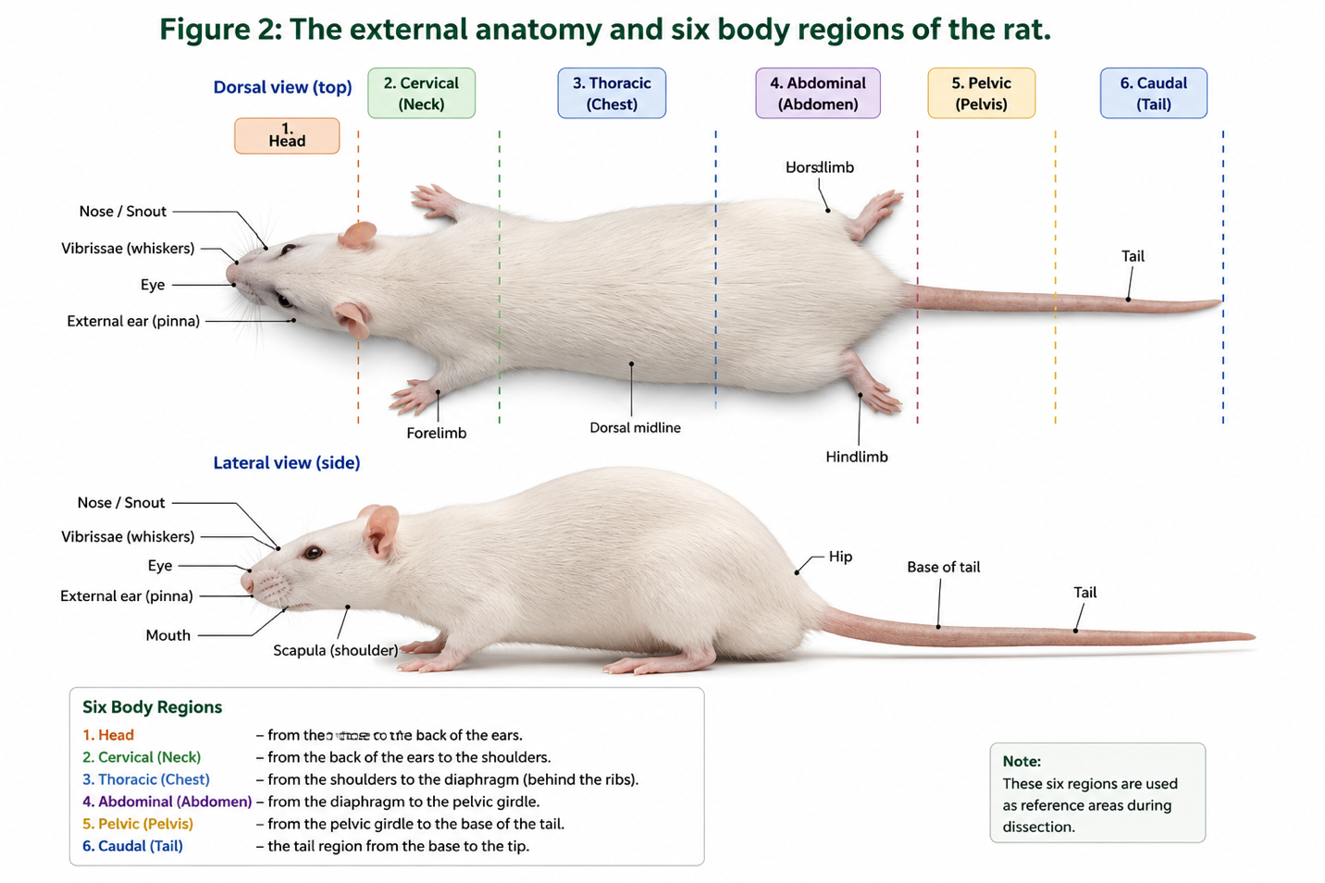
Figure 2: The external anatomy and six body regions of the rat.
The Dissection Procedure
Dissection follows a careful, ordered procedure. After preparing the specimen and examining it externally, the skin is lifted with forceps and snipped with scissors to expose the muscles, then the body cavity is opened to reveal the organs. Each structure is traced, identified and pinned for labelling, and the rat is stitched up and the area cleaned at the end. The golden rule is to never cut more than is necessary to expose a part.
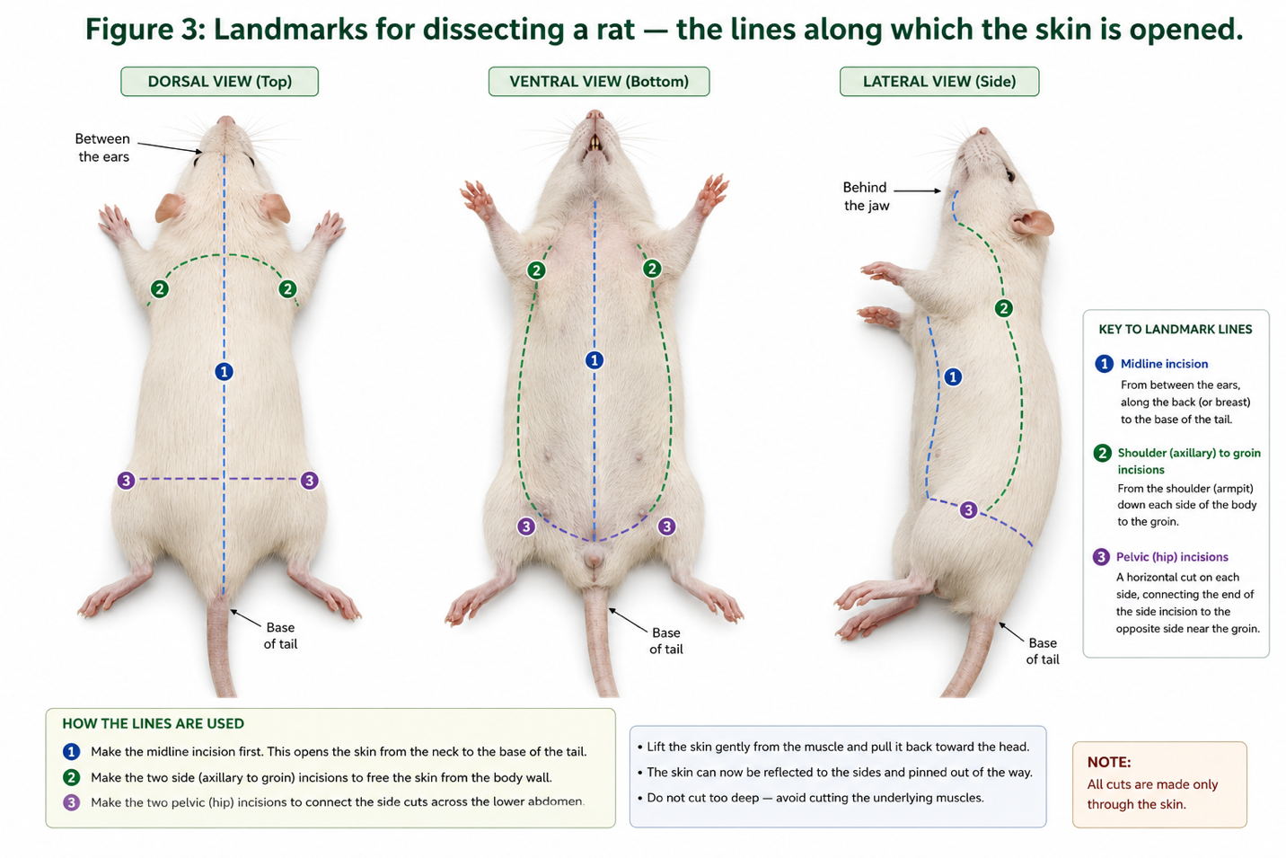
Figure 3: Landmarks for dissecting a rat - the lines along which the skin is opened.

The Muscular and Skeletal System
With the skin removed, the muscles are revealed and pinned for identification - for example the biceps and triceps brachii (upper arm), the gastrocnemius (calf, joined to the heel by the Achilles tendon), the biceps femoris (thigh), the external oblique (abdomen) and the pectoralis (chest). Teasing the muscles away exposes the bones: the femur (thigh), the tibia and fibula (lower leg) and the small patella (kneecap), with the hip forming a ball-and-socket joint.

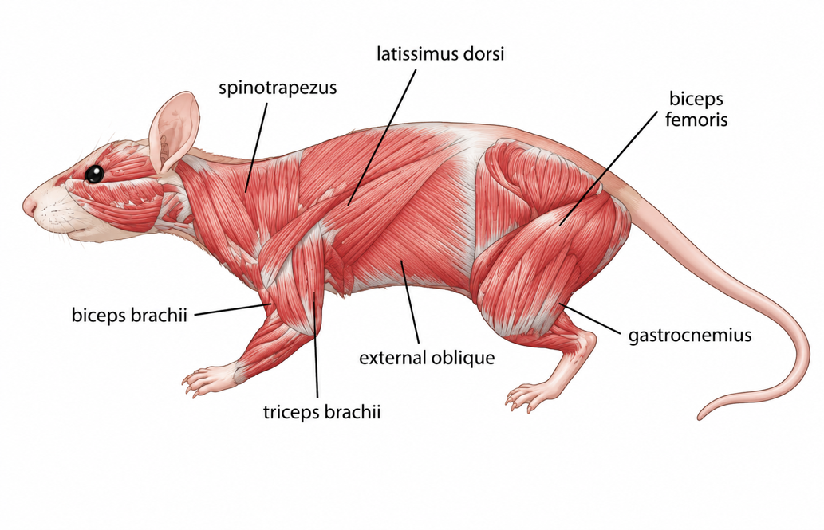
Figure 4: The main muscles of the rat.
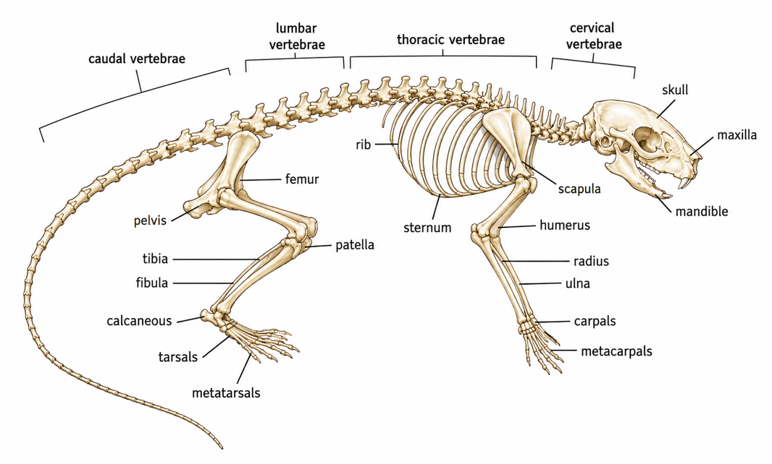
Figure 5: The skeleton of the rat.
The Internal Organs - Thoracic and Abdominal Cavities
Opening the body cavity reveals the internal organs. In the thoracic cavity lie the heart (in its pericardium) and the two lungs, with the ringed trachea and the larynx (voice box) in the neck; the diaphragm separates the chest from the abdomen. In the abdominal cavity are the liver (the largest organ, just below the diaphragm), the stomach, the coiled small intestine (duodenum, jejunum, ileum), the colon (large intestine), the pancreas (which makes digestive enzymes and insulin) and the spleen (which destroys old blood cells).
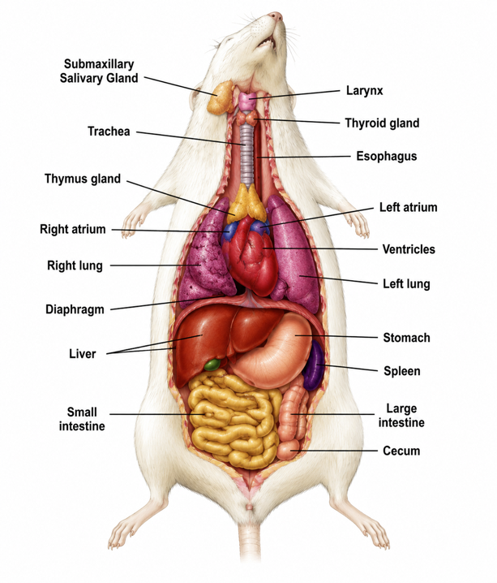
Figure 6: The thoracic and abdominal organs of the rat.
The Urogenital System
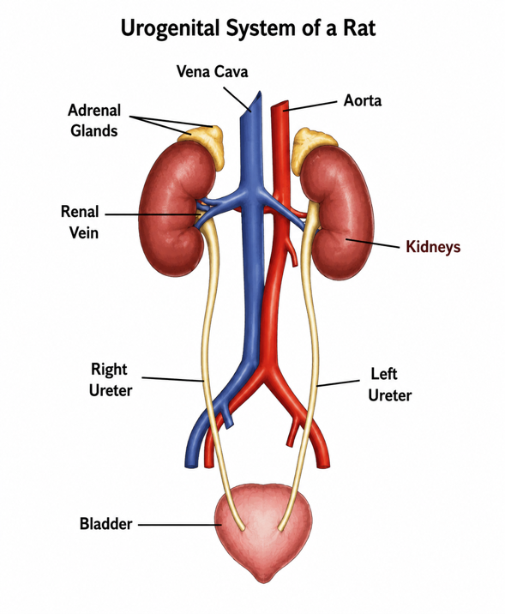
The excretory and reproductive systems are closely linked and are studied together as the urogenital system. The excretory organs are the bean-shaped kidneys (at the back of the abdomen, supplied by renal arteries and veins), the ureters that carry urine to the bladder, and the urethra. The reproductive organs are the testes in the male, and the ovaries and uterus in the female.

Figure 7: The urogenital system of the rat (excretory and reproductive organs).
Comparing the Rat with the Human Body
The whole point of the dissection is comparison. For every structure seen in the rat - a heart, a lung, a kidney, a length of intestine - there is an equivalent structure in the human body that does the same job. The similarity of these structures across related animals is evidence of common ancestry, and it is why the rat is so useful for understanding human anatomy and physiology, and for training surgical skills.
Worked Example - Tracing the Digestive Path
Follow food through the rat's digestive system, naming each organ:
- Oesophagus - carries food from the mouth down to the stomach.
- Stomach - stores and begins to digest the food.
- Small intestine (duodenum → jejunum → ileum) - most digestion and absorption.
- Liver & pancreas - add bile and digestive enzymes to the small intestine.
- Colon (large intestine) → rectum → anus - absorbs water and removes waste.
Each of these organs has a direct equivalent in your own digestive system, doing the very same job.
Why This Matters
- Understanding anatomy - dissection shows how organs and systems are really arranged.
- Structure and function - it links each structure to the job it performs and to the human body.
- Practical skills - it builds careful observation, instrument handling and surgical technique.
- Responsibility - it teaches safe, ethical and respectful handling of specimens.
PNG Context Example
Dissection skills support training in medicine, surgery, veterinary science and agriculture across Papua New Guinea. Careful observation, clean technique and an understanding of mammalian anatomy underpin the work of doctors, nurses, surgeons and animal-health workers - and the comparison between the rat and the human body gives students a practical foundation for further study in the health sciences.
References & Related Documents
Source Documents
- STEM Biology Student Resource Book - Grade 12, Term 1. Module 12.1 Health and Medical Biology, Topic 4: Surgery: Dissection of Animals (Classification of the Rat; Dissection; External Anatomy; Muscular/Skeletal, Thoracic, Abdominal and Urogenital Systems; Stitching). Department of Education, PNG (2021).
- STEM Biology Syllabus - Grade 12, Term 1. Topic 4: Surgery: Dissection of Animals.
- Biology Standards-Based Syllabus, Grades 11 & 12 (PNG SBC 2020) - Strand 2: Life; research the components of the human body from cell to system and how they work together.
Further Reading & References
- OpenStax Anatomy & Physiology - An Introduction to the Human Body. https://openstax.org/books/anatomy-and-physiology
- Khan Academy - Human anatomy and physiology. https://www.khanacademy.org/science/biology

